**Chapter 4**

**IMPLEMENTATION**

**4.1 Frontend Implementation :**

**1-User**

Navbar :

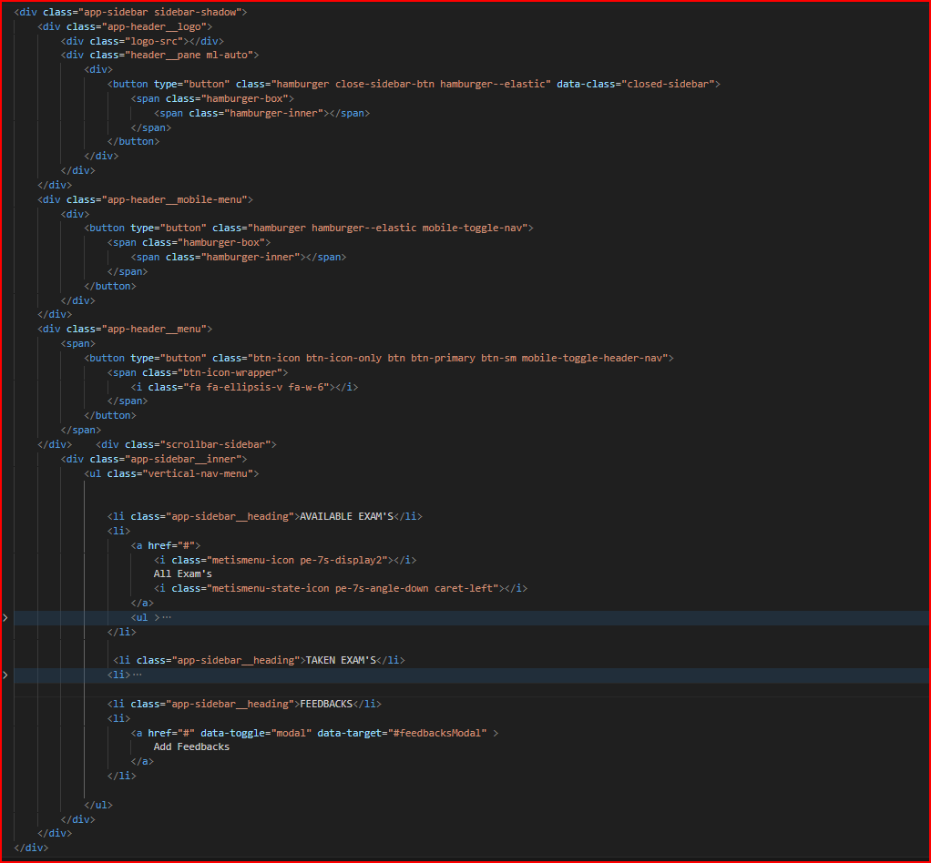

Figure 1.4 navbar code

A responsive navbar component is used to show a list of navigation links.We create navbar by using html, css and js A navigation bar (or navigation system) is a section of a graphical user interface intended to aid visitors in accessing information.. Add this class to a <nav> to define navbar component. Add this class to a <ul> to create navigation. Use <a> elements as menu item within the

List.

**Header :**

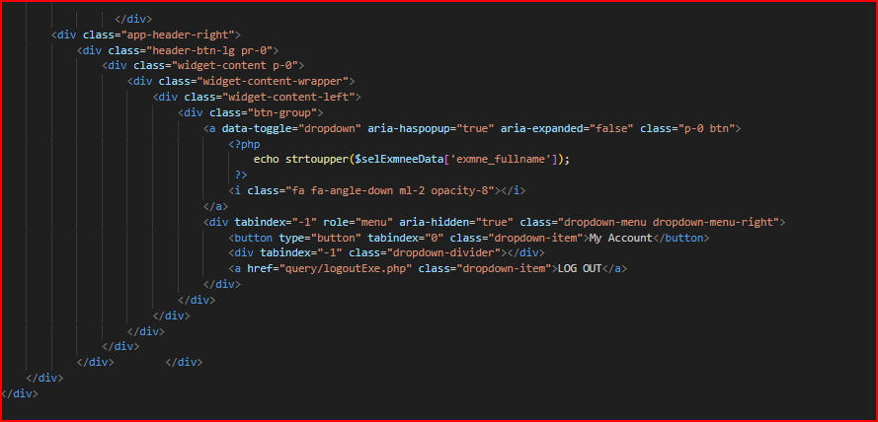

figure 2.4

The header is a part that is found on all pages and contains meta files, links to formatting files, a header section, and a body section 2.

**Links :**

**صورة تحتوي على نص, لقطة شاشة, الخط

تم إنشاء الوصف تلقائياً**

Figure 4.3

Linking JavaScript files such as the popper file, JQuery, and the website's JavaScript file.

صورة تحتوي على نص, لقطة شاشة, الخط

تم إنشاء الوصف تلقائياً

Figure 4.4

Linking CSS files to format such as the bootstrap file, icons, and its site format file.

صورة تحتوي على لقطة شاشة, نص

تم إنشاء الوصف تلقائياً

Figure 5.4

Show test and questions to answer 1.

صورة تحتوي على نص, لقطة شاشة, عرض, برمجيات

تم إنشاء الوصف تلقائياً

Figure 6.4

Show test and questions to answer 2.

صورة تحتوي على نص, لقطة شاشة

تم إنشاء الوصف تلقائياً

Figure 4.7 show results 1.

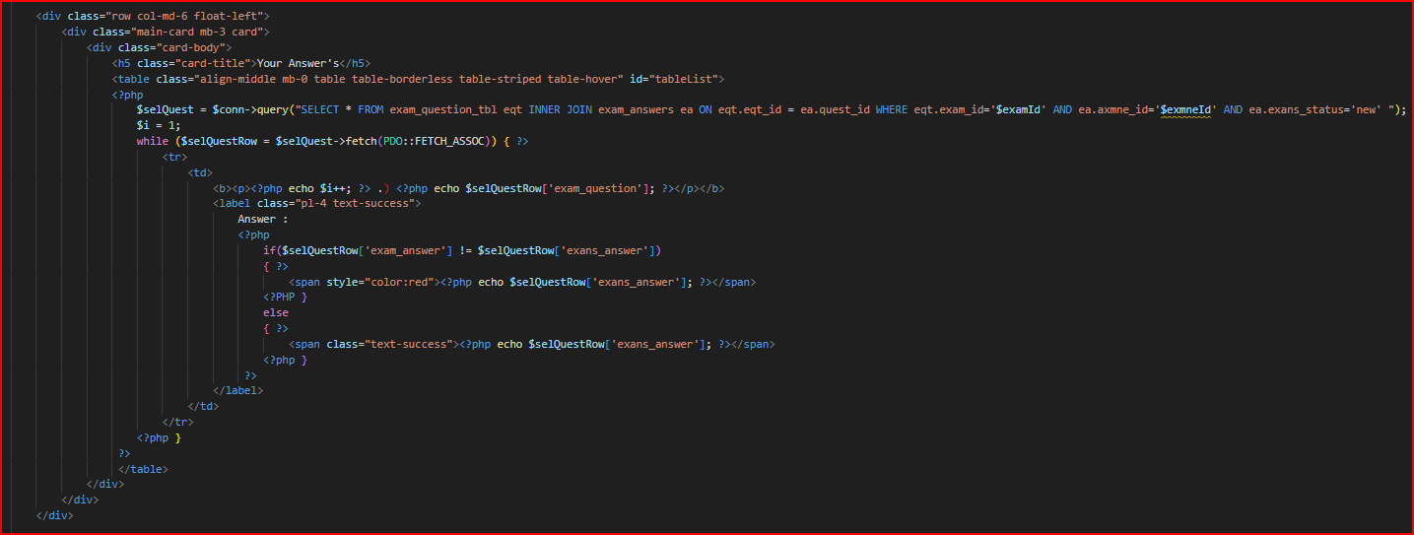

Figure 4.8 show results 2.

صورة تحتوي على نص, لقطة شاشة, عرض, برمجيات

تم إنشاء الوصف تلقائياً

Figure 4.9 show results 3.

**Login form :**

User login form to log in to access the student's powers to take the test and so on.

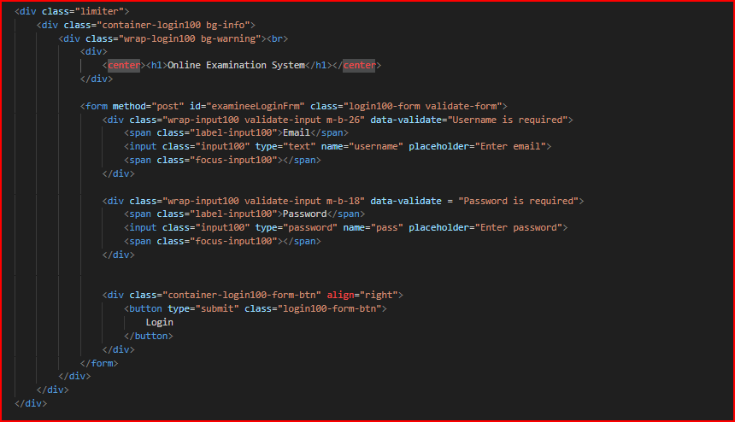

Figure 4.10

**2-Admin**

**Navbar :**

The side nav bar contains pages banks to access 1.

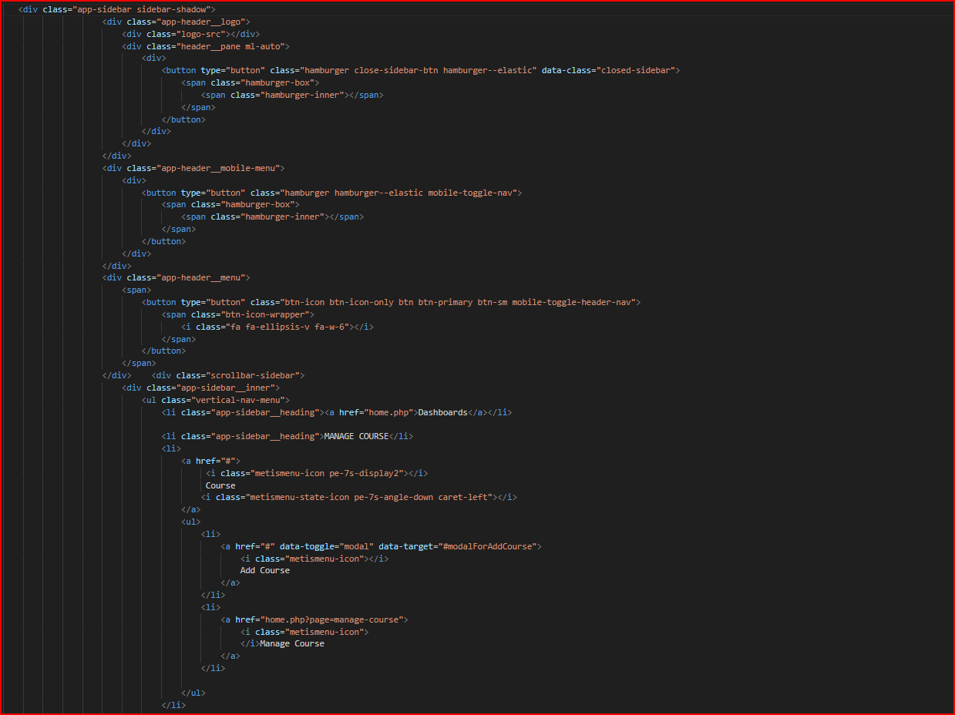

Figure 4.11

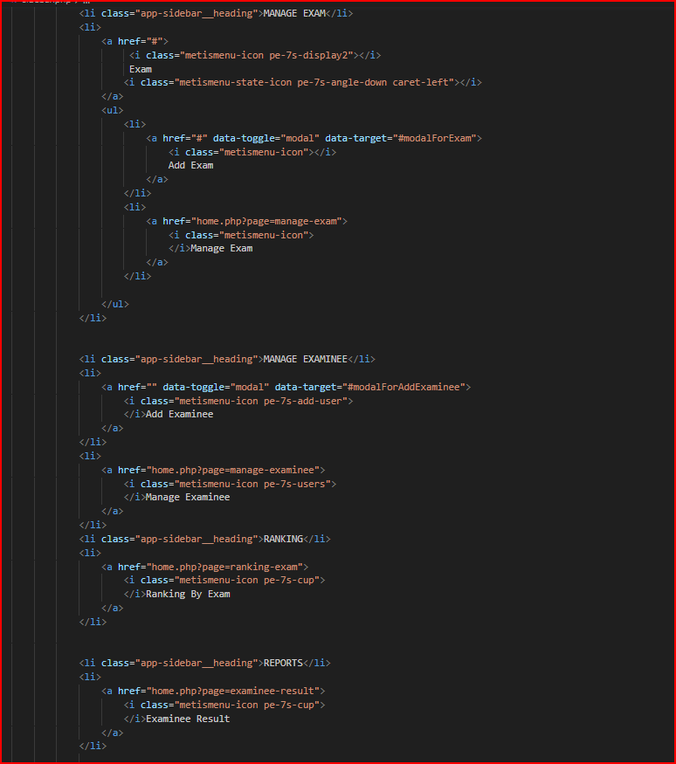

Figure 4.12 The side nav bar contains pages banks to access 2.

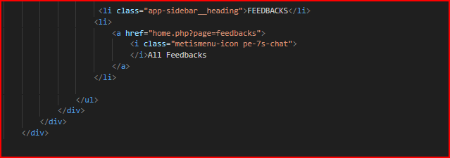

Figure 4.13 The side nav bar contains pages banks to access 3.

**Header :**

The header is a part that is present on all pages and contains meta files and links to formatting files, the header section, and the nav bar is transferred to the mobile system or vice versa, and the body section 1.

صورة تحتوي على نص, لقطة شاشة

تم إنشاء الوصف تلقائياً

Figure 4.14

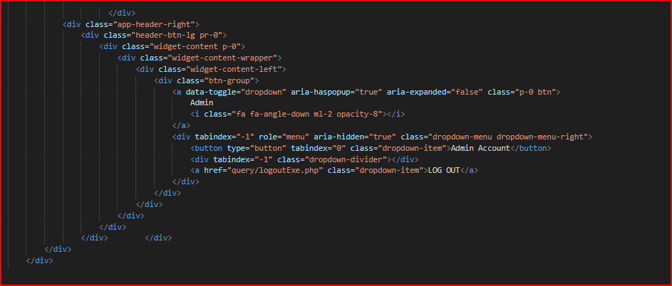

Figure 4.15

The header is a part that is present on all pages and contains meta files and links to formatting files, the header section, and the nav bar is transferred to the mobile system or vice versa, and the body section 2.

**Management :**

Management of testers or students, which is the part for adding testers or students and adding their data through the admin.

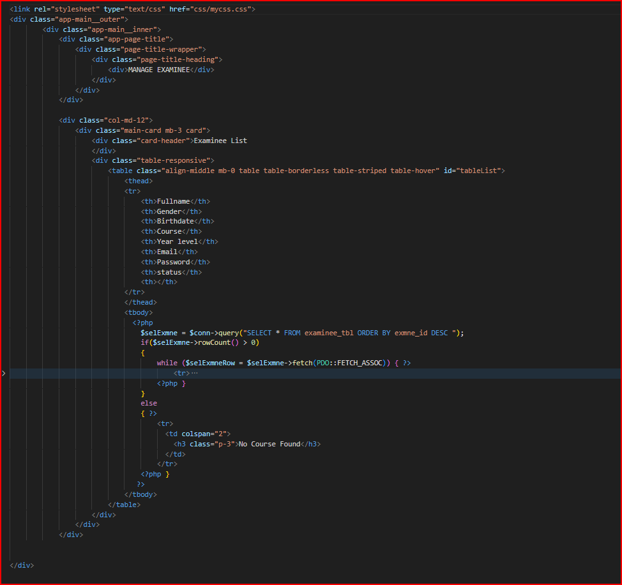

Figure 4.16

Course management, which is the part for managing courses, adding, deleting, modifying, adding questions, etc…… .

صورة تحتوي على نص, لقطة شاشة, برمجيات

تم إنشاء الوصف تلقائياً

Figure 4.17 menage courses.

Test management, which is the section for managing tests, adding, deleting, modifying, adding questions, etc……. .

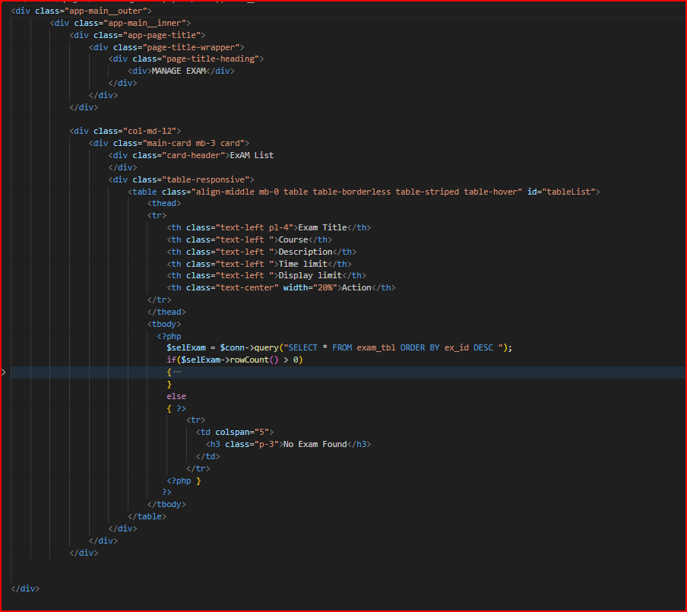

Figure 4.18 manage tests.

**Show Results:**

Displaying the final results of the site from two testers, the percentage of those who passed, and so on 1.

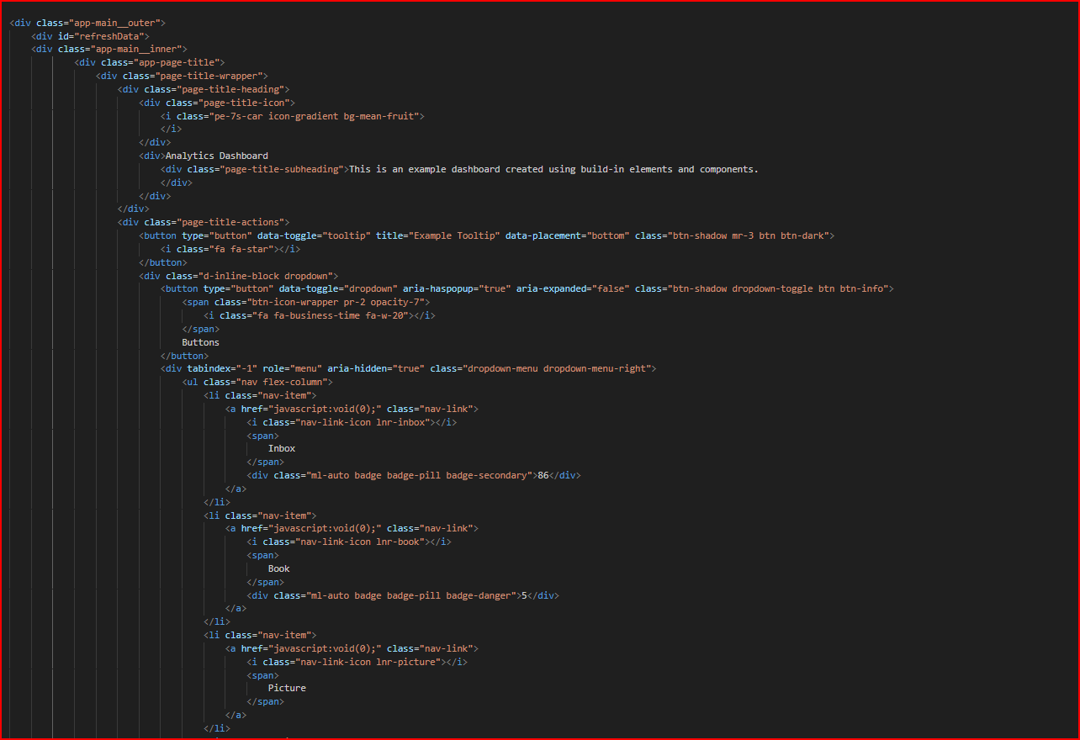

Figure 4.19

Displaying the final results of the site from two testers, the percentage of those who passed, and so on 2.

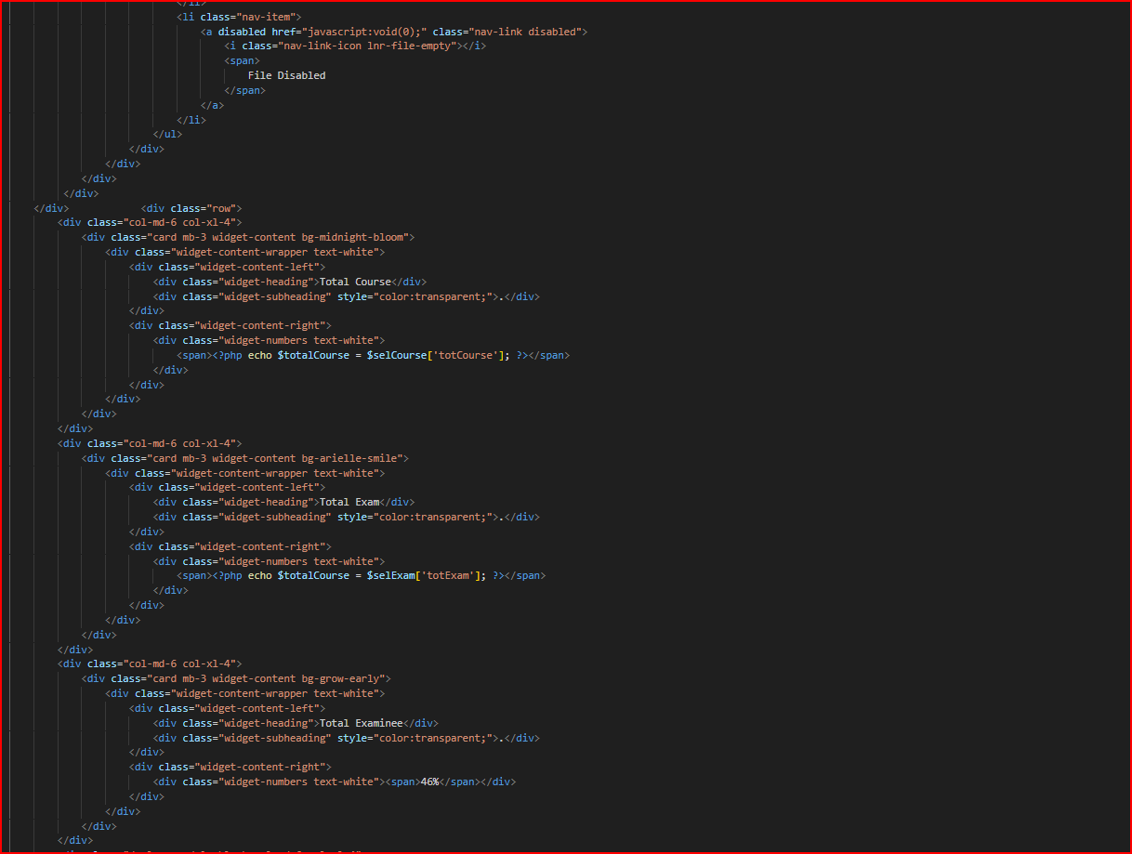

Figure 4.20

Displaying the final results of the site from two testers, the percentage of those who passed, and so on 3.

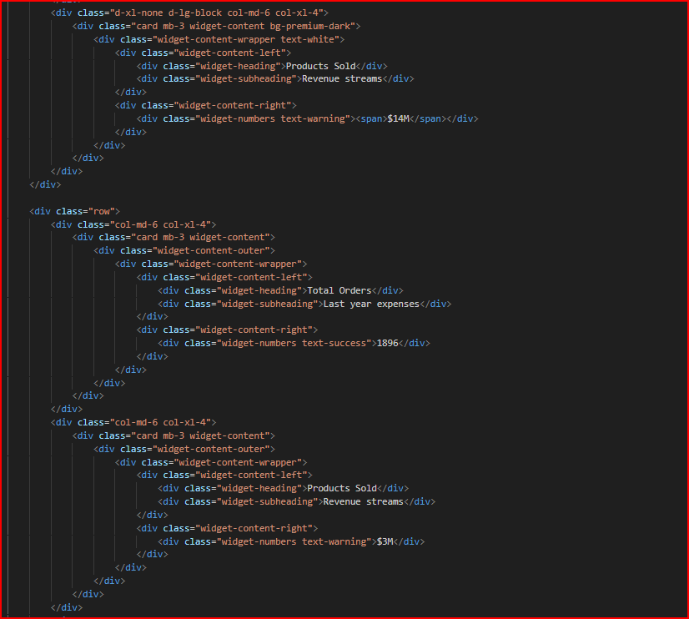

Figure 4.21

Displaying the final results of the site from two testers, the percentage of those who passed, and so on.

صورة تحتوي على نص, لقطة شاشة

تم إنشاء الوصف تلقائياً

Figure 4.22

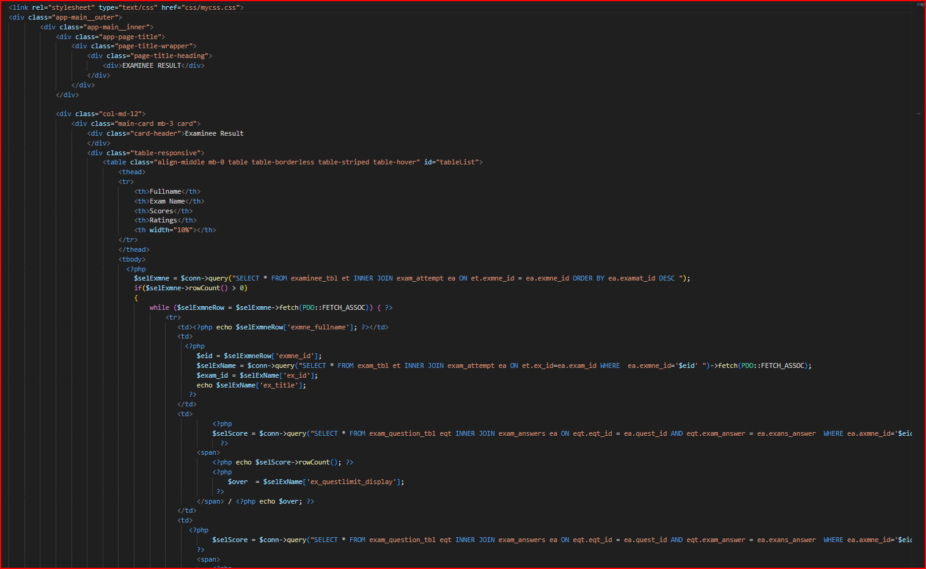

Figure 4.23

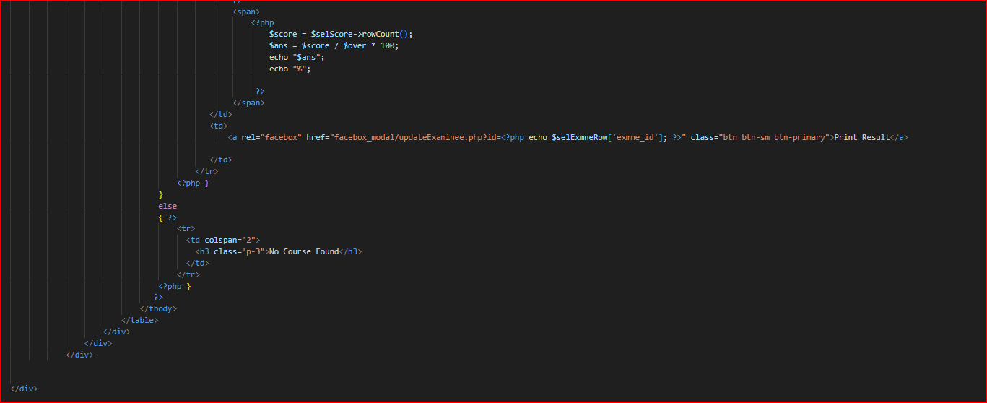

Figure 4.24 view tester results2 .

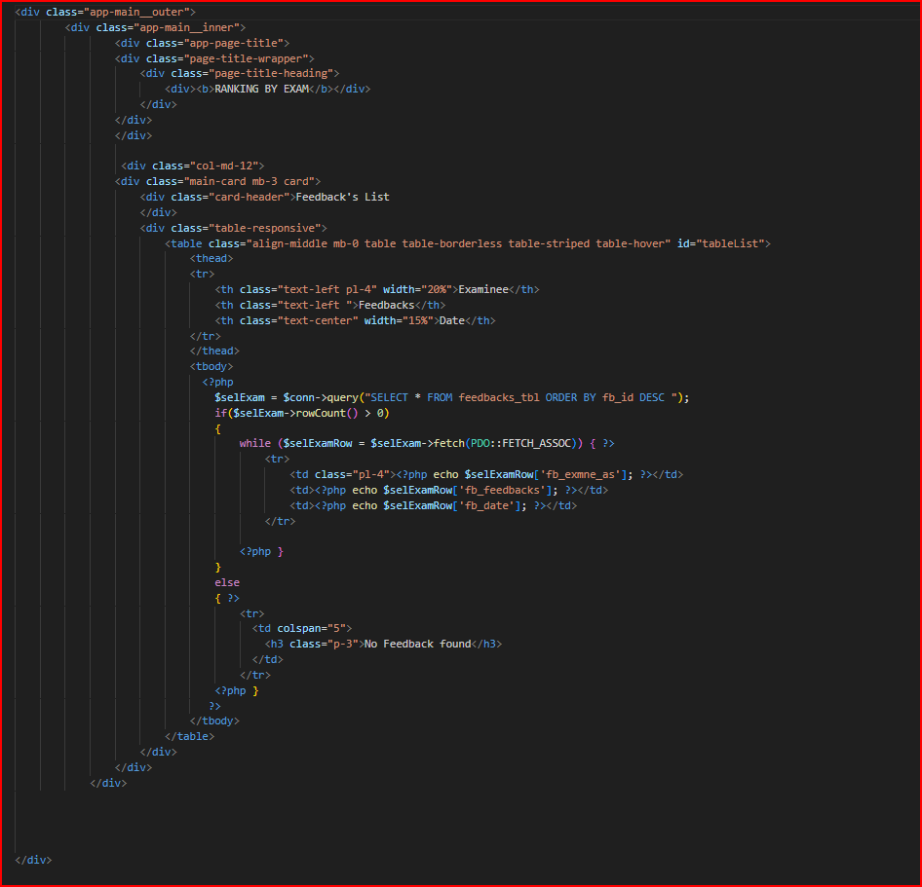

Figure 4.25 View all feed backs to help improve the site.

**Admin log in page :**

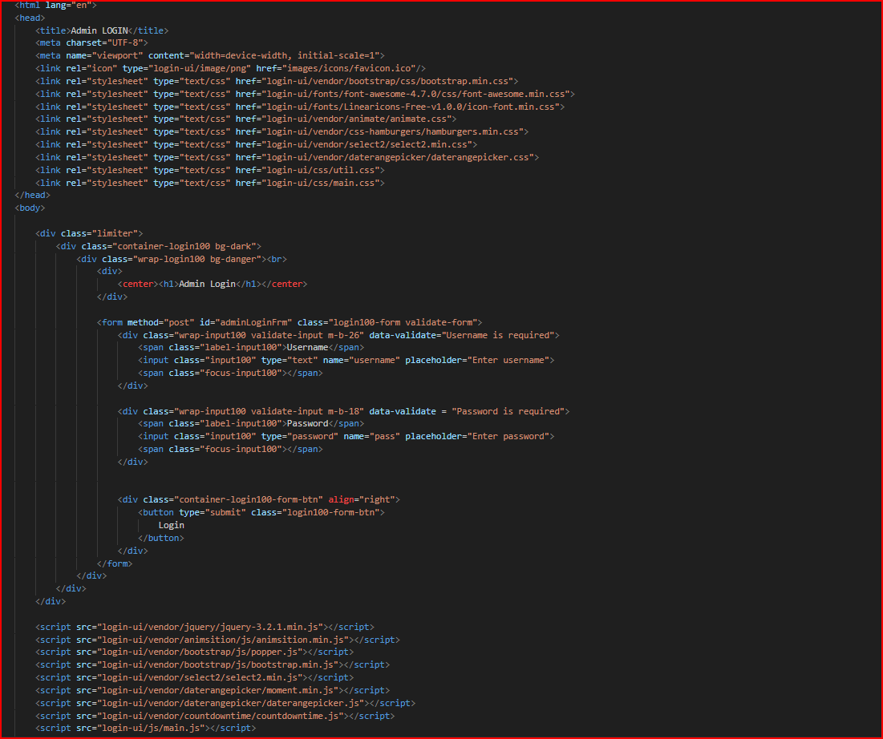

Figure 4.26

صورة تحتوي على نص, برمجيات, صفحة ويب, لقطة شاشة

تم إنشاء الوصف تلقائياً

Figure 4.27

Displaying the final results of the site from two testers, the percentage of successful students, and so on 5.

**Back-End Implimentaion:** **4.2**

**1-User**

Log in as a user to take the exam.

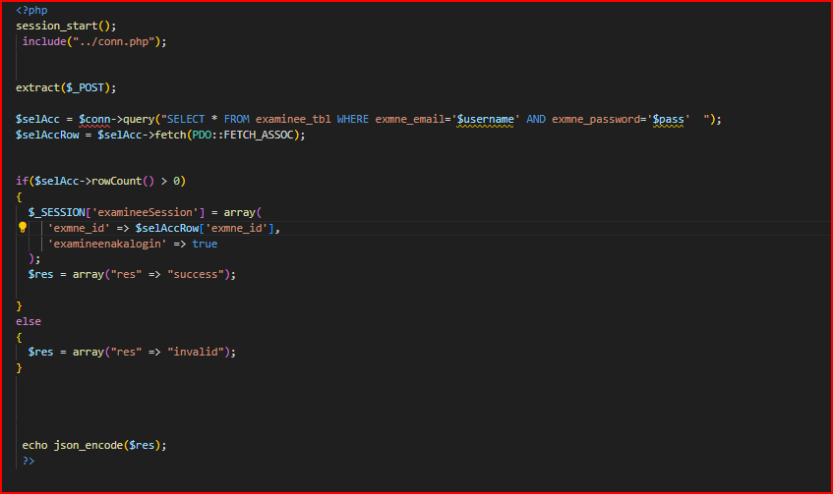

Figure 4.28

Fetch test data and questions.

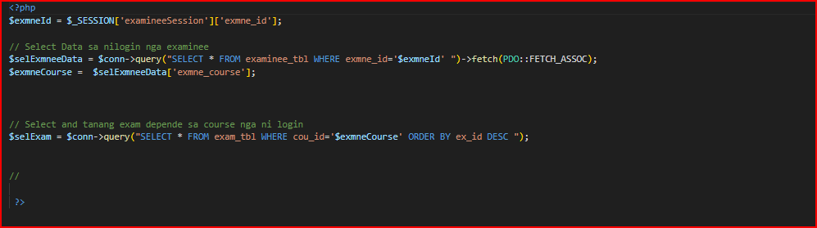

Figure 4.29

Adding answers to the questions that have been answered after selecting the answers 1.

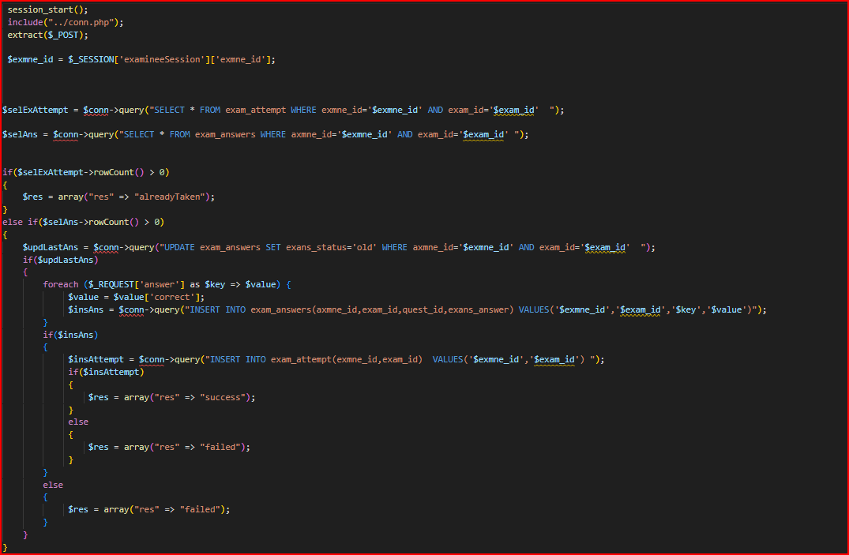

Figure 4.30

Adding answers to the questions that have been answered after selecting the answers 2.

صورة تحتوي على نص, لقطة شاشة, برمجيات, عرض

تم إنشاء الوصف تلقائياً

Figure 4.31

View the tests that have been tested.

صورة تحتوي على نص, لقطة شاشة, برمجيات

تم إنشاء الوصف تلقائياً

Figure 4.32

Add suggestions for improvement of the site.

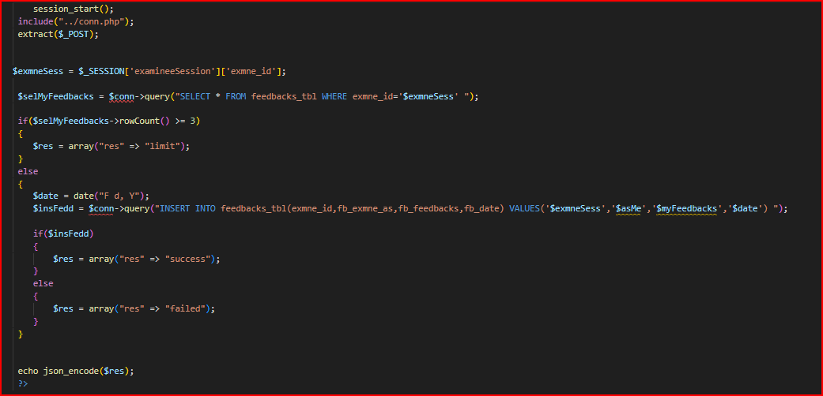

Figure 4.33

**User-Ajax :**

**Log in**

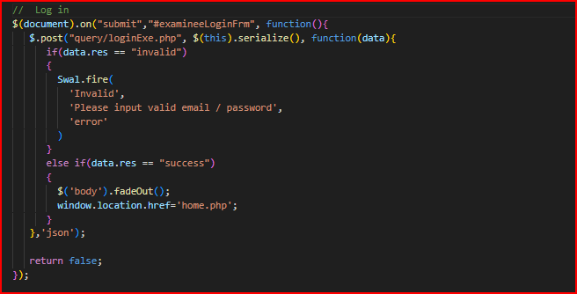

Figure 4.34

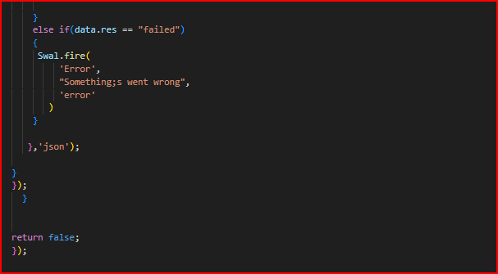

Figure 4.35 submit answer.

صورة تحتوي على نص, لقطة شاشة

تم إنشاء الوصف تلقائياً

Figure 4.36 Submit answer.

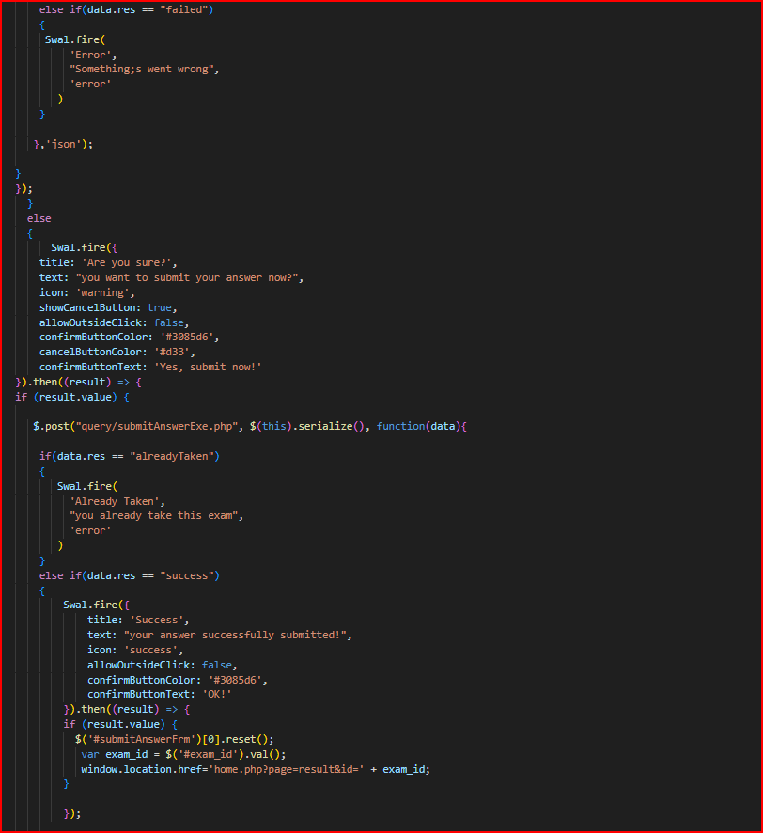

Figure 4.37 submit answer.

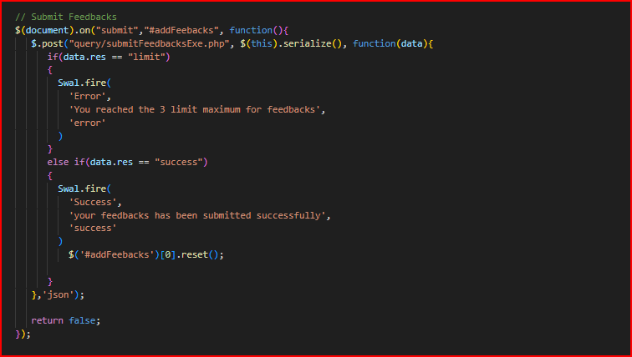

Figure 4.38 Submit feedback.

**2-Admin**

Adding tests to courses or subjects.

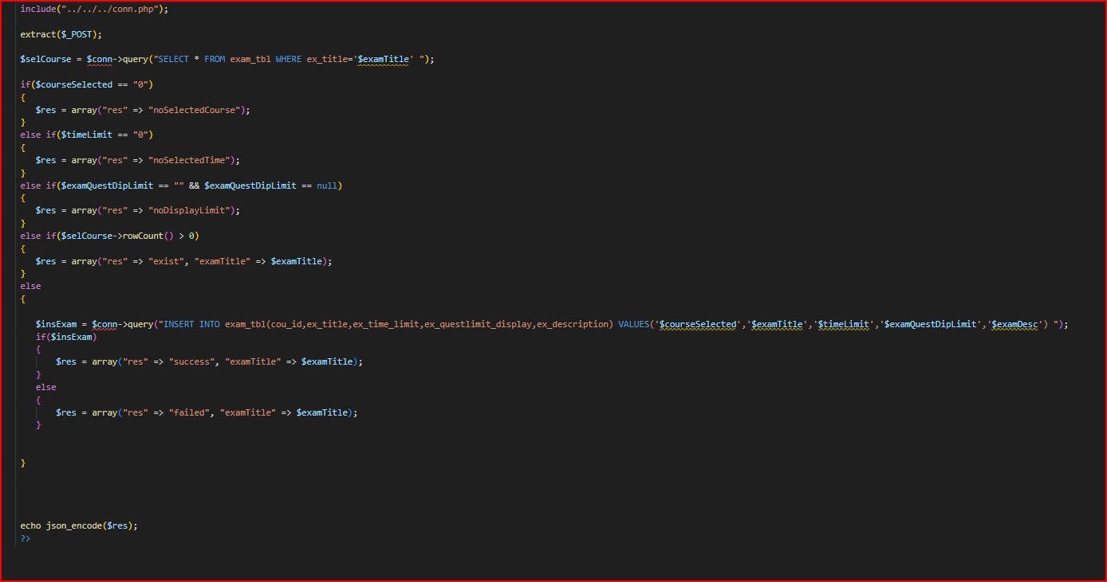

Figure 4.39

Adding questions to the uploaded tests.

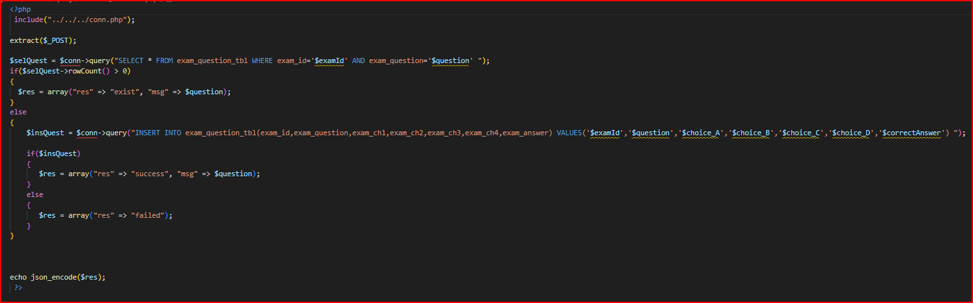

Figure 4.40

Adding courses or subjects to be tested.

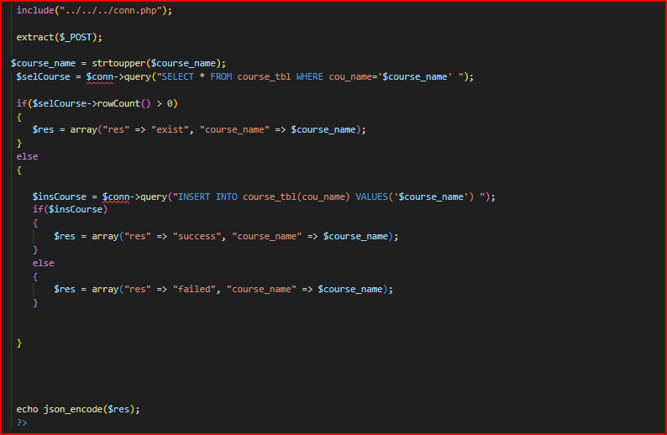

Figure 4.41

Log in as an admin to reach the admin managements.

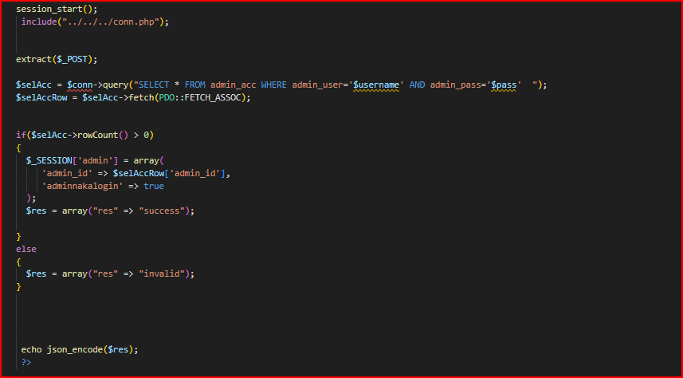

Figure 4.42

Manage questions and answers.

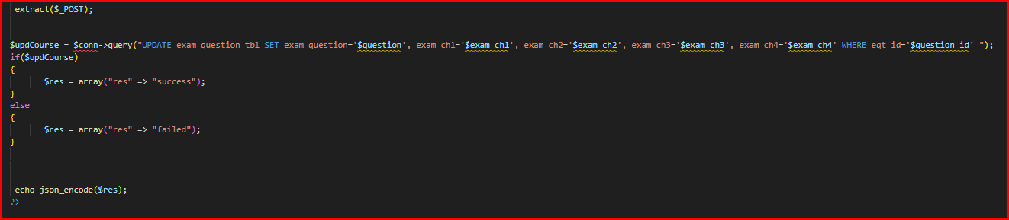

Figure 4.43

Manage data of the tests.

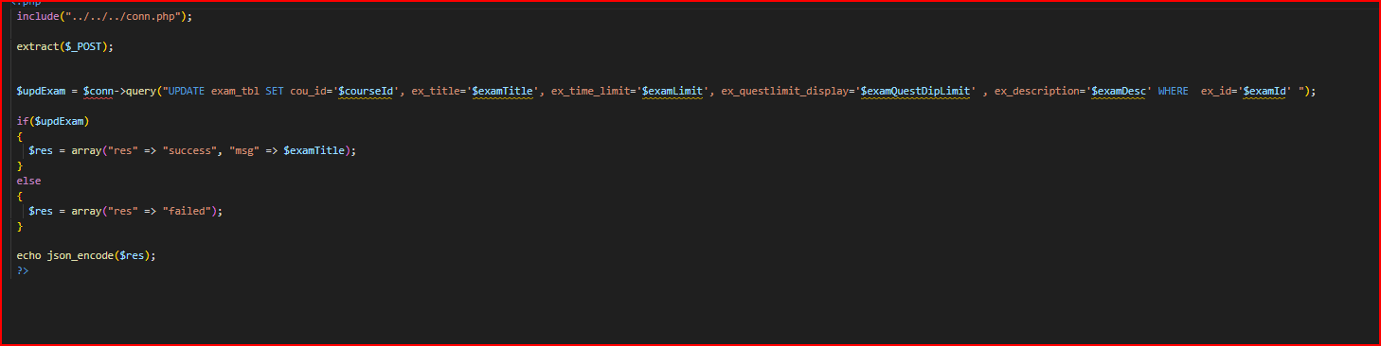

Figure 4.44

Manage data of the courses.

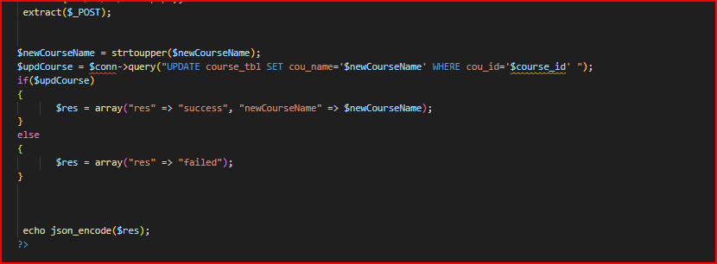

Figure 4.45

Manage data of the testers or students.

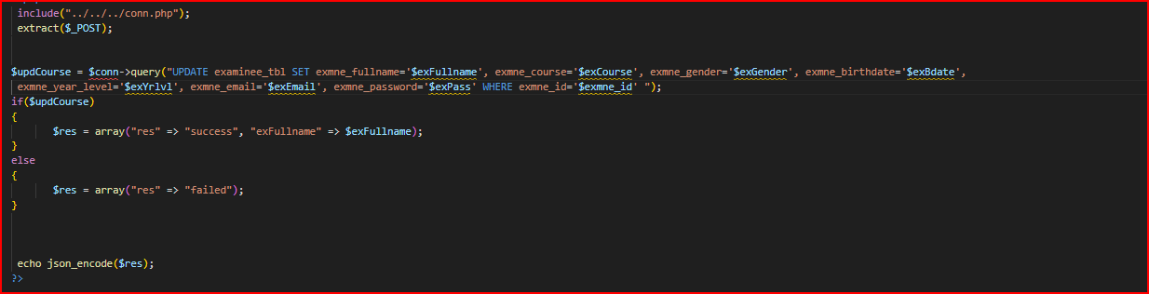

Figure 4.46

Adding testers to take the tests.

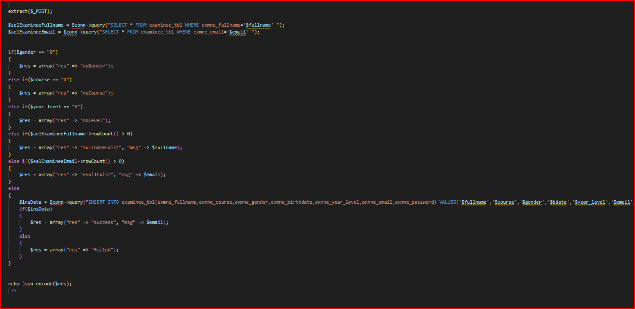

Figure 4.47

Count the number of data like courses or tests.

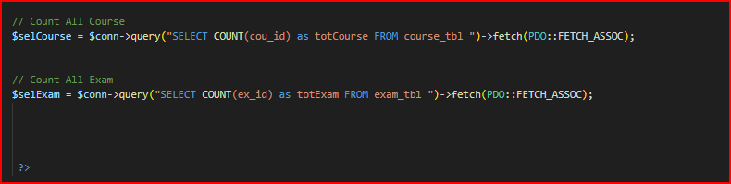

Figure 4.48

Delete courses that have been added before.

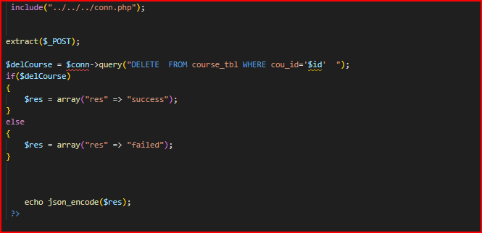

Figure 4.49

Delete tests that have been added before.

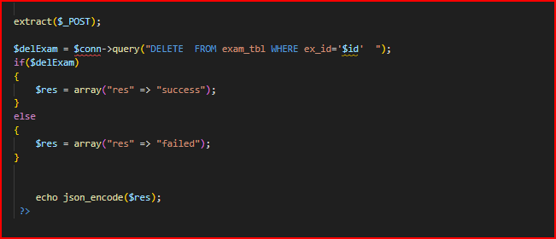

Figure 4.50

Delete questions that have been added before.

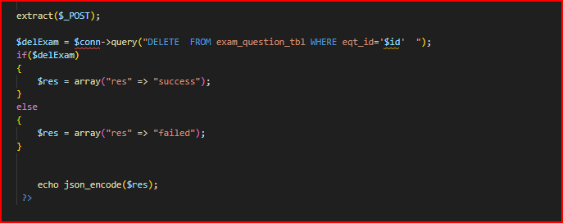

Figure 4.51

**Admin-ajax:**

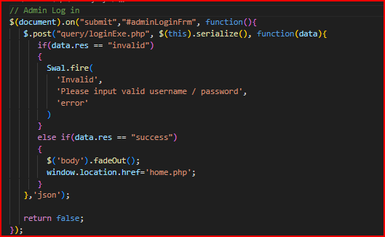

Figure 4.52 Log in.

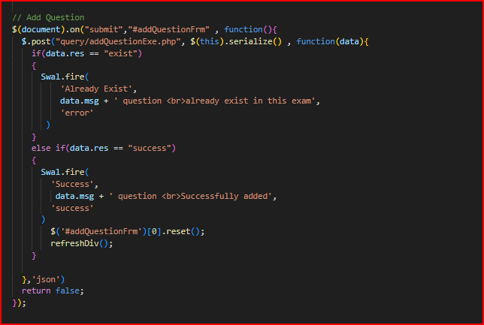

Figure 4.53 Add question.

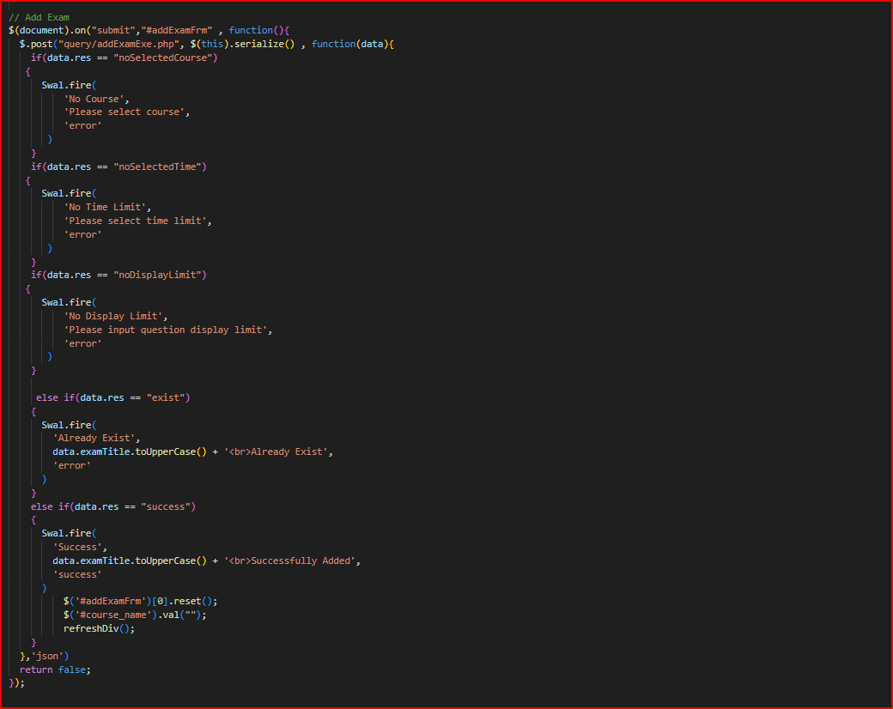

Figure 4.54 Add exam.

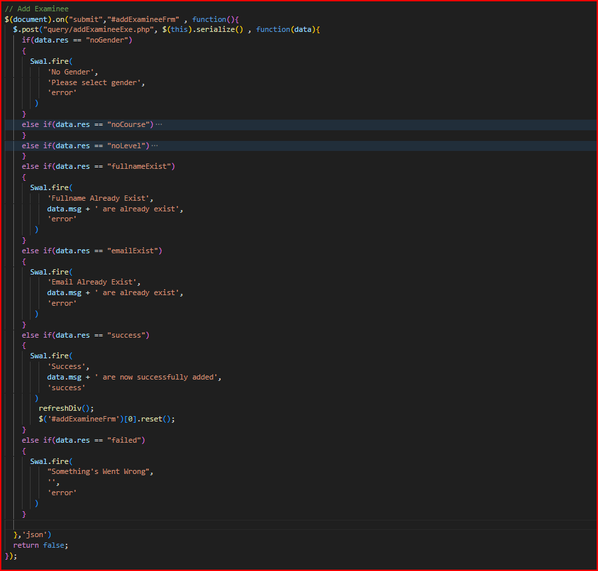

Figure 4.55 Add examinee.

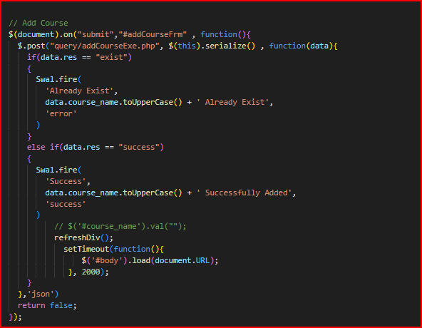

Figure 4.56 Add course.

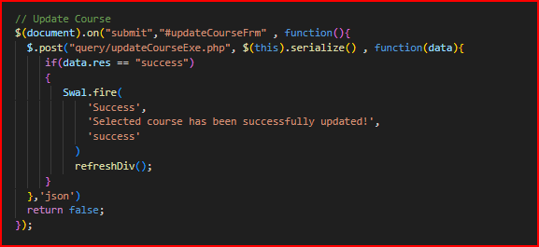

Figure 4.57 Update course.

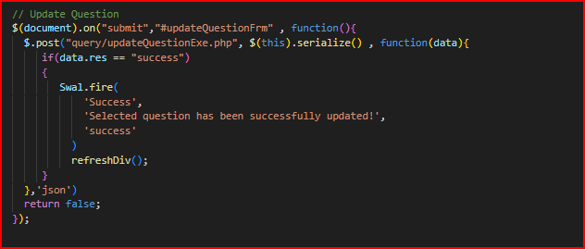

Figure 4.58 Update question.

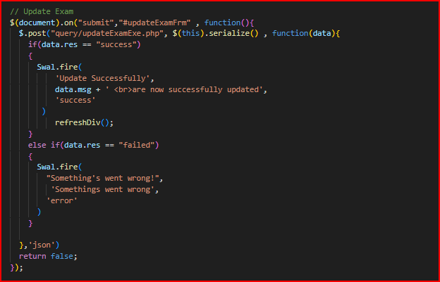

Figure 4.59 Update exam.

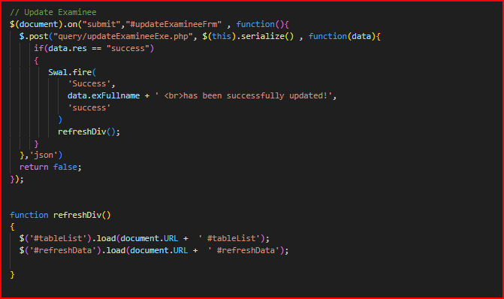

Figure 4.60 Update examinee.

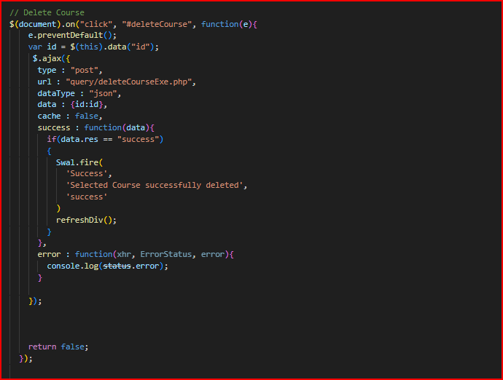

Figure 4.61 Delete course.

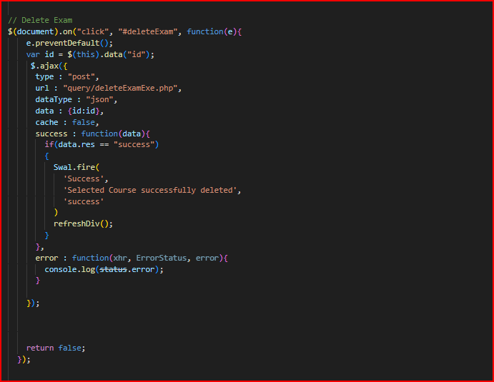

Figure 4.62 Delete exam.

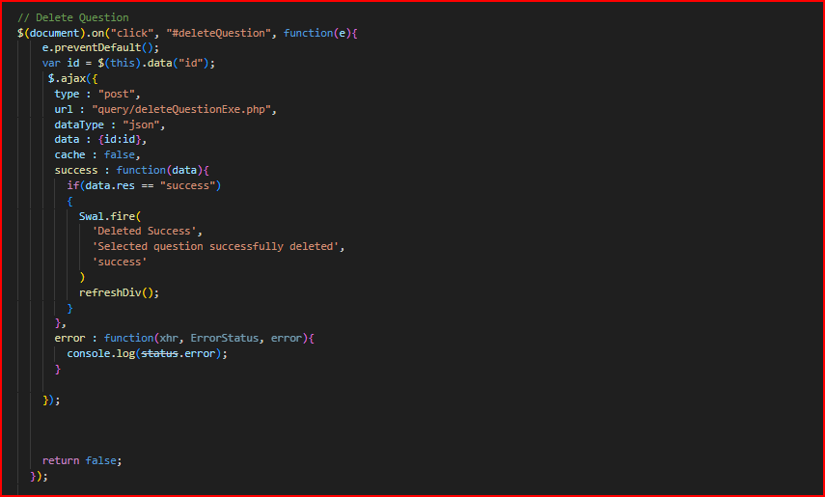

Figure 4.63 Delete question.

**General :**

Log out and deleting all sessions.

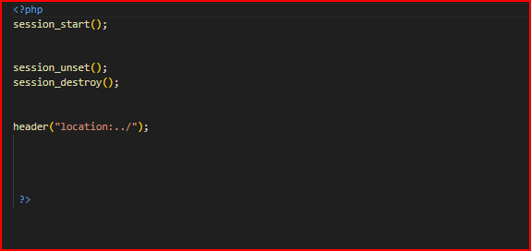

Figure 4.64

Database connection.

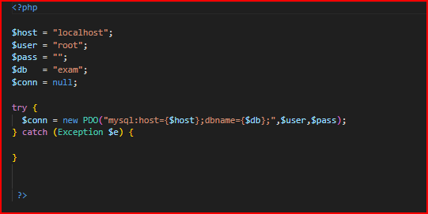

Figure 4.65

**3-database implementation**

In databases , a table is defined as set of data elements organized

into columns (they are named) and horizontal rows A table has a

specified number of columns, but it can contain any number of

rows. The row is defined by the values that appear in a part of the

columns called the candidate key.

**In the database for this project there are four tables:**

**1-Admin table:**

Its code:-

صورة تحتوي على نص, لقطة شاشة, الخط, الجبر

تم إنشاء الوصف تلقائياً

Table 1 Admin table

This table contains the login permissions represented in the id which is the primary key ,user and password.

**2-Course table:**

This table represents the main factors for creating a course.

Its code:-

**صورة تحتوي على نص, لقطة شاشة, الخط

تم إنشاء الوصف تلقائياً**

Table 2 Course table

**3-Examinee table:**

It represents all the elements that are required to be available in the student who will take the exam.

صورة تحتوي على نص, لقطة شاشة, الخط

تم إنشاء الوصف تلقائياً

table 3 Examinee table

**4-Exam answers table:**

It contains ids for the exam answer, examinee, exam and question, also elements necessary for getting from user a well defined answer.

-Its code:

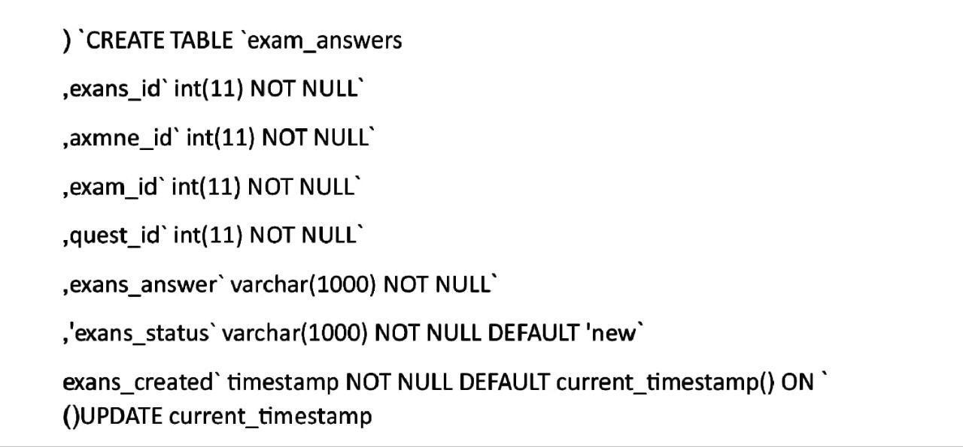

Table 4 Exam answer

**5-Exam attempt table:**

Here are the the exam attempt id and both ids of examinee and the exam.

-Its code:

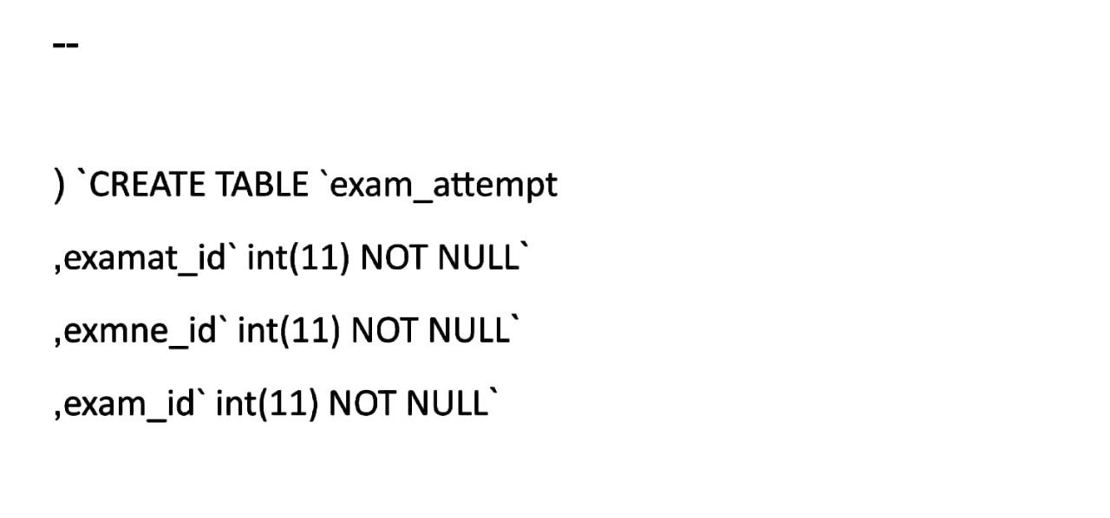

Table 5 Exam attempt

**6-Exam question table:**

This table contains question id and exam id, also it has an exam questions and answers for valid chapters which are both varchar in length of 1000.

-Its code:

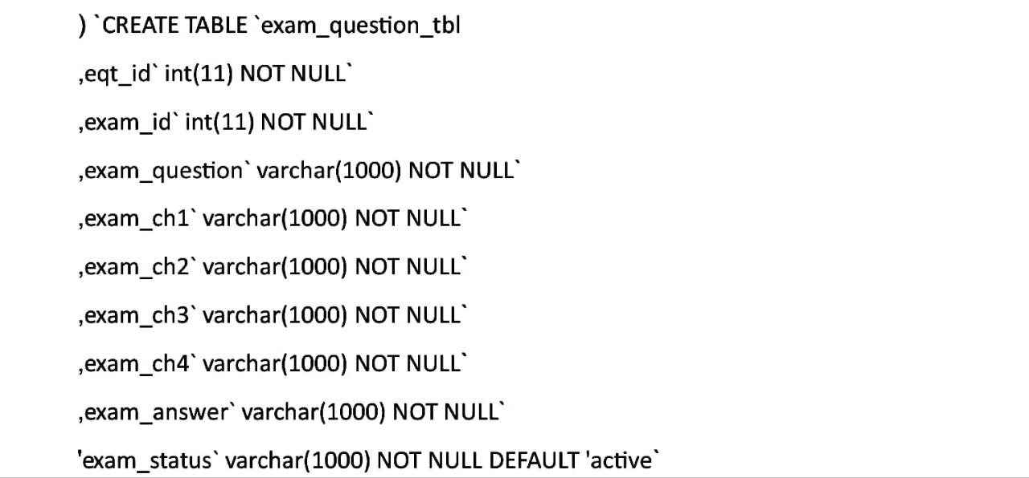

Table 6 Exam questions

**7-exam table:**

this table has exam id and course id, with title, limit, description and timestamp for the exam.

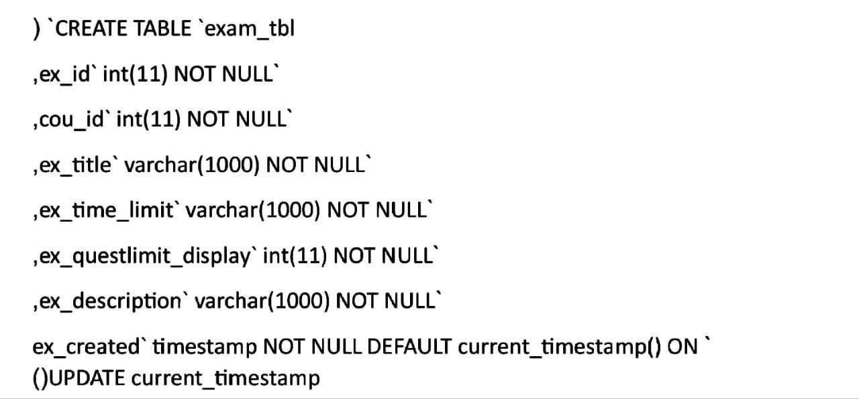

Table 7 Exam table

**8-Feedback table:**

It contains a feedback id and the exam id, also the examinee, feedback and date all varchar of length (1000).

-Its code:

صورة تحتوي على نص, الخط, لقطة شاشة

تم إنشاء الوصف تلقائياً

Table 8 Feedback table